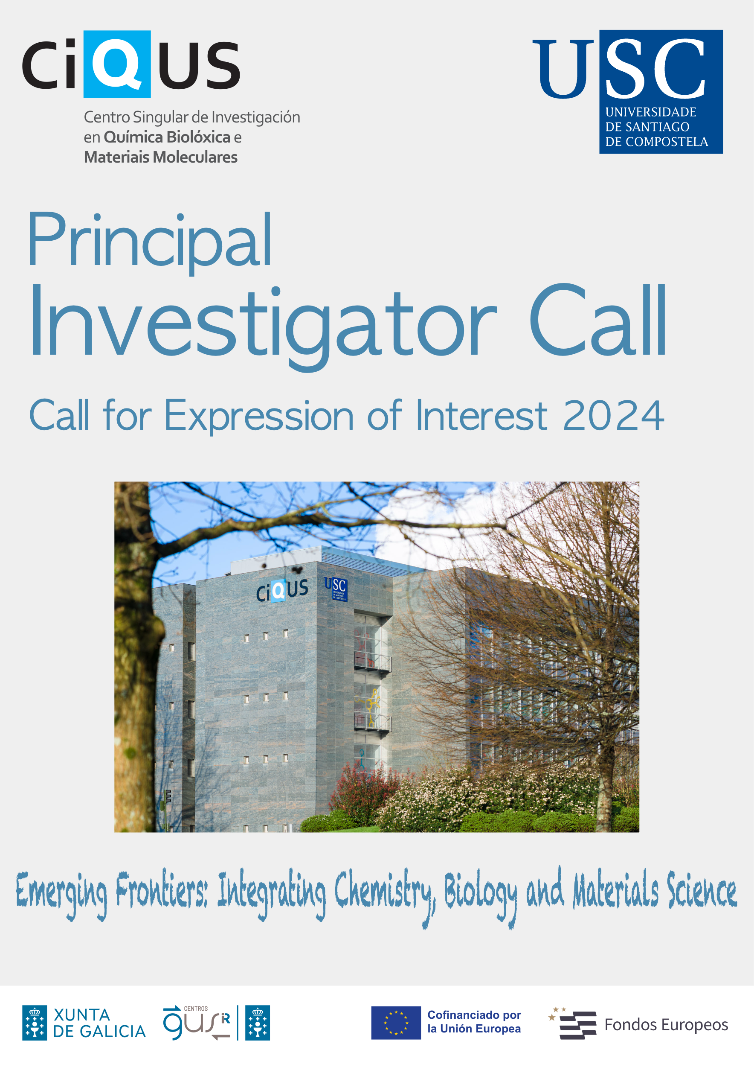
ANNEX
EXPRESSION OF INTEREST to become a Principal Investigator (PI) at the Centro Singular de Investigación en Química Biolóxica e Mateirais Moleculares (CiQUS)

NAME:
CURRENT POSITION:
DEPARTMENT/CENTER:
Ph. D. (date and title):

I. Expression of Interest
(Research field in connection with the thematic orientation of the Center, previous experience in cooperative research, etc. Applicants should briefly explain how their scientific profile aligns with CiQUS's strategic objectives, how their incorporation will further enhance CiQUS's international competitiveness, and how joining the center will contribute to advancing their scientific career; max. 700 words)

II. Project
(Short description of the project to be developed in the Center. max. 300 words)

III. Biographical sketch
(max 300 words)

IV. Scientific projects/contracts (participation as PI)
(Please indicate the title, duration and budget of projects and relevant research/development contracts. Additionally, current international grant applications under evaluation and/or “in preparation” should be mentioned)

V. Selection of scientific articles/patents
(Please select up to 10 scientific contributions –articles and licensed patents– with indication of title, complete list of authors, journal, volume, pages, publication year and any other relevant information)

VI. Other indicators (optional)
(Please choose any indicator you consider of interest to support the relevance of your scientific career: e.g. h-index, accumulated impact factor, number of citations, editorial board membership, international plenary lectures).

Please indicate if the research project that you propose (as PI) would be developed in the context of an existing research team at CiQUS.
NO
YES Name of the current CiQUS PIs/team:

